**Screen shot of the Multi Year Stock Analysis Data – VBA**

Homework for 06/22/2020

Bejirose Stanly

Year 2014

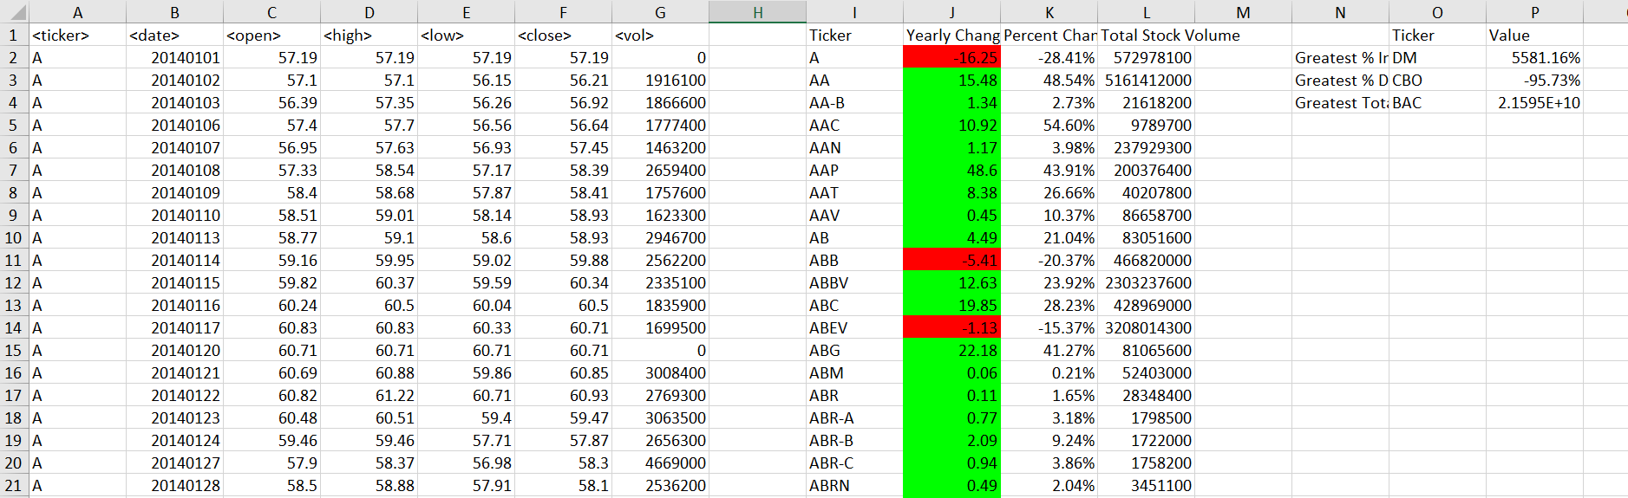

Year 2015

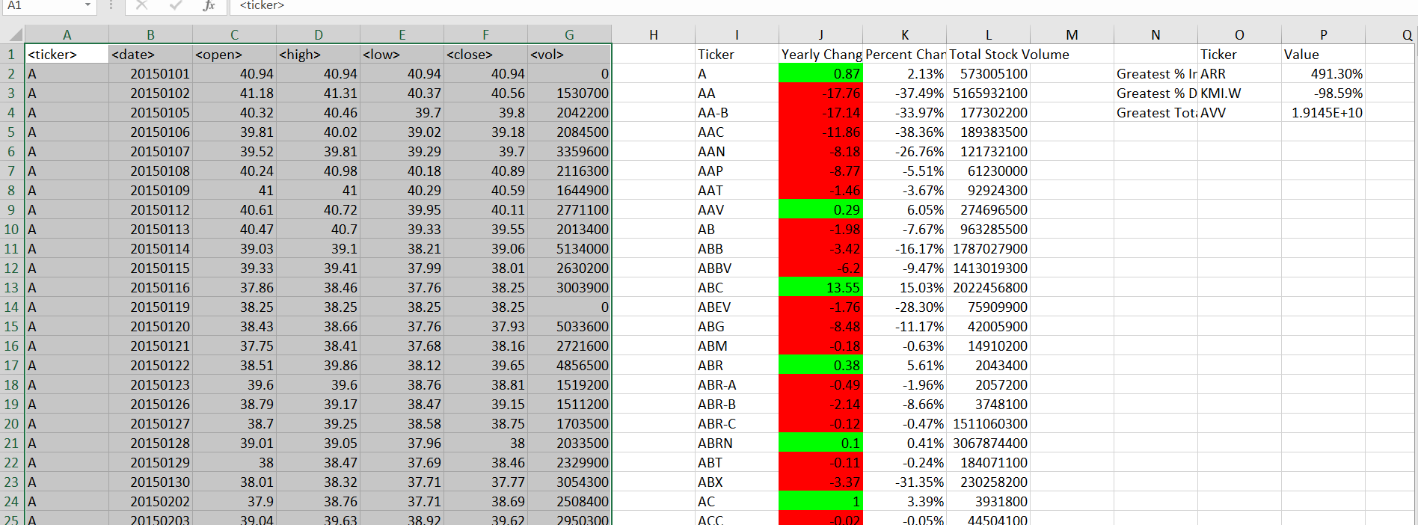

Year 2016

